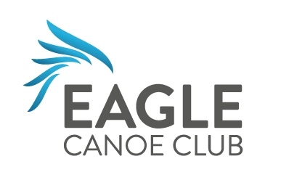
Mission Statement and Club Values

Mission Statement
To provide a friendly welcoming club, where all paddlers can develop in a safe and fun environment.

Club Values
- Friendly
- Approachable
- Inclusive
- Supportive and Encouraging
- Enjoyable and Fun
- Offers a range of opportunities
- Inspiring

